** MINISTRY OF EDUCATION AND TRAINING**

**FPT UNIVERSITY**

Capstone Project Document

**Computer Product Suggestion**

|  |  |
| --- | --- |
| **Group 1** | |
| **Group member** | Pham Hong Sang – Team Leader – SE60601  Huynh Thanh Viet – Team Member - SE60666  Tran Tan Len – Team Member - SE60623  Ha Chi Danh – Team Member - 60431 |
| **Supervisor** | Mr. Kieu Trong Khanh |
| **Ext. Supervisor** | N/A |
| **Capstone Project code** | CPS |

-Ho Chi Minh City, 05/2014-

*This page is intentionally left blank*

***ACKNOWLEDGEMENTS***

We wish to thank various people for their contribution to this project: Our teachers for their advice and participation in the final review, our friends for their valuable technical support.

Special thanks should be given to Mr.Kiều Trọng Khánh, our research supervisor for his professional guidance and the useful, constructive recommendations throughout the course of this project.

# Table of Contents

Table of Contents 4

List of Tables 5

List of Figures 6

Definitions, Acronyms, and Abbreviations 8

Report No.3 Software Requirement Specification 9

1. User Requirement Specification 9

1.1 Guest Requirement 9

1.2 Member Requirement 9

1.3 Staff Requirement 9

1.4 Admin Requirement 9

1.5 System Requirement 9

2. System Requirement Specification 9

2.1 External Interface Requirement 9

2.2 System Overview Use Case 10

2.3 List of Use Case 10

3. Software System Attribute 48

3.1 Usability 48

3.2 Reliability 48

3.3 Availability 48

3.4 Security 48

3.5 Maintainability 48

3.6 Portability 48

3.7 Performance 49

4. ERD 50

# List of Tables

Table 1: <Admin> Configure System 11

Table 2: <Admin> Make Statistics 12

Table 3: <Admin> Create User 14

Table 4: <Admin> Update User 15

Table 5: <Admin> Activate User 16

Table 6: <Admin> Deactivate User 17

Table 7: <Admin> Force Parse Data 19

Table 8: <System> Auto Parse Data 20

Table 9: <Staff> Create Market 23

Table 10: <Staff> Update Market 25

Table 11: <Staff> Deactivate Market 26

Table 12: <Staff> Activate Market 28

Table 13: <Staff> Import File 30

Table 14: <Staff> Manually Input 32

Table 15: <Staff> Update Product 33

Table 16: <Staff> Deactivate Product 34

Table 17: <Staff> Activate Product 36

Table 18: <Member> Ask For System Suggestion 37

Table 19: <Member> Search Product and View Product Price 39

Table 20: <Member> Add Product To Cart 40

Table 21: <Member> Propose Price 41

Table 22: <Member> Save Product History 42

Table 23: <Member> Logout 43

Table 24: <Guest> Login 45

Table 25: <Guest> Register 47

# List of Figures

Figure 1: System Overview Use Case 9

Figure 2: <Admin> Overview use case 10

Figure 3: <Admin> Configure System 10

Figure 4: <Admin> Make Statistics 11

Figure 5: <Admin> Create User 12

Figure 6: <Admin> Update User 14

Figure 7: <Admin> Active User 15

Figure 8: <Admin> Deactivate User 16

Figure 9: <Admin> Force Parse Data 18

Figure 10: <System> Overview Use Case 19

Figure 11: <System> Auto Parse Data 19

Figure 12: <Staff> Overview Use Case 21

Figure 13: <Staff> Create Market 21

Figure 14: <Staff> Update Market 23

Figure 15: <Staff> Deactivate Market 25

Figure 16: <Staff> Activate Market 27

Figure 17: <Staff> Import File 28

Figure 18: <Staff> Manually Input 30

Figure 19: <Staff> Update Product 32

Figure 20: <Staff> Deactivate Product 33

Figure 21: <Staff> Activate Product 35

Figure 22: <Member> Overview Use Case 36

Figure 23: <Instructor> Ask For System Suggestion 36

Figure 24: <Member> Search Product and View Product Price 37

Figure 25: <Member> Add Product To Cart 39

Figure 26: <Member> Propose Price 40

Figure 27: <Member> Save Product History 41

Figure 28: <Member> Logout 43

Figure 29: <Guest> Overview Use Case 44

Figure 30: <Guest> Login 44

Figure 31: <Guest> Register 45

Figure 35: ERD - Conceptual Diagram 49

# Definitions, Acronyms, and Abbreviations

|  |  |
| --- | --- |
| CPS | Computer Product Suggestion |

# Report No.3 Software Requirement Specification

## User Requirement Specification

### Guest Requirement

Guest is a person who doesn’t have access to the system. Guest can use some functions in the system. To use all functions, guest must login. These are some functions guest can use:

* Register.
* Ask for system suggestion.
* Search product.
* Add product to cart.

### Member Requirement

Member is guest who uses his account to login to the system. Member can use additional functions, such as:

* Update product price.
* Save product history.

### Staff Requirement

Staff is the person who manages markets and products. Staff can use these functions:

* Manage market.
* Manage product.

### Admin Requirement

Admin is the person who manages the system. Admin can use these functions:

* Configure system.
* Make statistics.
* Manage user.

### System Requirement

System is also an actor, run in the background to keep the system working. System can do functions:

* Parse data.

## System Requirement Specification

### External Interface Requirement

#### User Interface

* + The interface of website is clear, do not annoy customer.
  + The error, warning messages must be make clear, easy to understand. Error warning does not disturb customer.

#### Hardware Interface

* + The system will use the standard hardware and data communications resources of a standard computer.

#### Software Interface

* + Firefox Browser, Chromes with Resolution (1024*768) or bigger and support JavaScript and HTML5.

#### Communication Protocol

* Website using HTTP protocol for communication between the web browser and the web server.

### System Overview Use Case

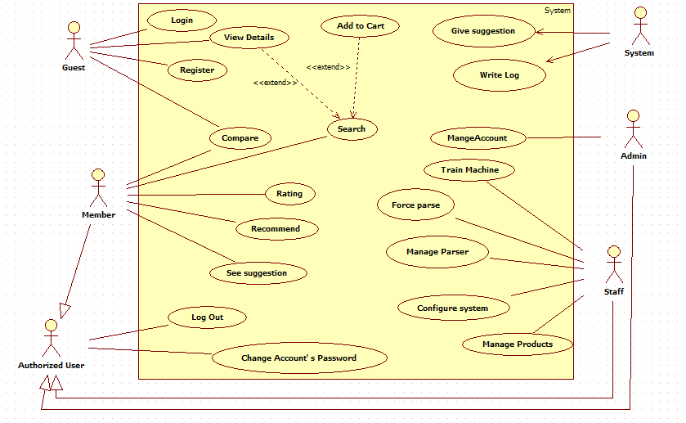

Figure 1: System Overview Use Case

### List of Use Case

#### <Admin> Overview Use Cases

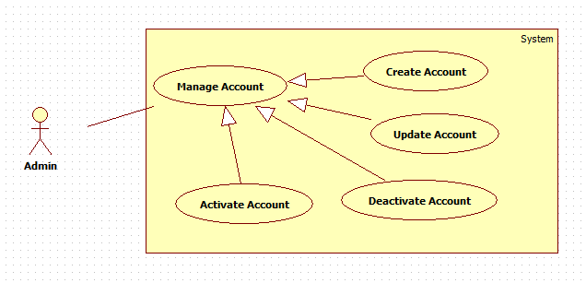

Figure 2: <Admin> Overview use case

##### <Admin> Create Account



Figure 3: <Admin> Create Account

|  |  |  |  |
| --- | --- | --- | --- |
| **USE CASE – CPS001** | | | |
| **Use Case No.** | CPS001 | **Use Case Version** | 1.0 |
| **Use Case Name** | Create account | | |
| **Author** | Tran Tan Len | | |
| **Date** | 28/05/2014 | **Priority** | Normal |
| **Actor:**   * Admin   **Summary:**   * This use case allows admin to create new account in the system.   **Goal:**   * New account will be added to the system.   **Triggers:**   * Admin wants to create new account. * From the sidebar:   + Choose “Quản lý tài khoản” menu.   + Choose “Tạo tại khoản mới” button.   **Preconditions:**   * User must login the system with admin role.   **Post Conditions:**   * **Success:** New account will be added to the database. * **Fail:** Show error message on the current page.   **Main Success Scenario:**   |  |  |  | | --- | --- | --- | | Step | Actor Action | System Response | | 1 | Click menu item “Quản lý tài khoản”. | Navigate to “Quản lý tài khoản” page which contains:   * “Tạo tài khoản mới” button. * A table with 5 columns:   + Tên Tài Khoản.   + Email.   + Vai trò.   + Kích Hoạt.   + Sửa. * “Tên Tài Khoản”: label. * “Địa chỉ Email”: label. * “Vai trò”: label. * “Hoạt Động”: button or “Ngưng Hoạt Động”: button * “Sửa”: button. | | 2 | Admin clicks “Tạo tài khoản mới” button. | Navigate to “Tạo tài khoản mới” popup which contains:   * Tên tài khoản: textbox, min length: 5, max length: 100, required. * Mật khẩu: textbox, min length: 5, max length: 100, required. * Xác nhận mật khẩu: textbox, min length: 5, max length: 100, required. * Địa chỉ Email:regular expression: /^[_a-z0-9-]+(\.[_a-z0-9-]+)*@@[a-z0-9-]+(\.[a-z0-9-]+)*(\.[a-z]{2,4})$/ required. * Vai trò: drop down list, “admin" default. * “Tạo tài khoản”: button. * “Xóa Trắng”: button. | | 3 | Admin fills data to the form.  Admin clicks “Tạo tài khoản” button.  [Alternative 1] | Insert new account to the database and close popup  [Exception 1, 2, 3,4,5] |   **Alternative Scenario:**   |  |  |  | | --- | --- | --- | | No | Actor Action | System Response | | 1 | Admin clicks “Xóa Trắng” button”. | Clear all input data. |   **Exceptions:**   |  |  |  | | --- | --- | --- | | No | Actor Action | System Response | | 1 | “Tên Tài Khoản”is not in range [5-100]. | “Tên Tài Khoản” textbox border color is red. | | 2 | “Mật Khẩu” is not in range  [5-100]. | “Mật Khẩu” textbox border color is red. | | 3 | “Tên Tài Khoản” has already existed. | Show message: “Tài khoản đã tồn tại!” and “Tên Tài Khoản” textbox border color is red. | | 4 | “Xác nhận mật khẩu” not similer “Mật Khẩu” | “Mật Khẩu” textbox border color is red.  “Xác Nhận Mật Khẩu” textbox border color is red. | | 5 | Invalid email format. | “Email” textbox border color is red. |   **Relationships:** N/A  **Business Rules:**   * Each created account must be in active state when insert to database. | | | |

##### Table 1: <Admin> Create Account

##### <Admin> Update Account



Figure 4: <Admin> Update Account

|  |  |  |  |
| --- | --- | --- | --- |
| **USE CASE – CPS002** | | | |
| **Use Case No.** | CPS002 | **Use Case Version** | 1.0 |
| **Use Case Name** | Update account | | |
| **Author** | Tran Tan Len | | |
| **Date** | 28/05/2014 | **Priority** | Normal |
| **Actor:**   * Admin   **Summary:**   * This use case allows admin to update information for user accounts.   **Goal:**   * New information will be updated to the database.   **Triggers:**   * Admin wants to change some information.   **Preconditions:**   * User must log in system with admin role.   **Post Conditions:**   * **Success:** New information will be updated to the database. * **Fail:** Show error message.   **Main Success Scenario:**   |  |  |  | | --- | --- | --- | | Step | Actor Action | System Response | | 1 | Click menu item “Quản lý tài khoản”. | Navigate to “Quản lý tài khoản” page which contains:   * “Tạo tài khoản mới” button. * A table with 5 columns:   + Tên Tài Khoản.   + Email.   + Vai trò.   + Kích Hoạt.   + Sửa. * “Tên Tài Khoản”: label. * “Địa chỉ Email”: label. * “Vai trò”: label. * “Hoạt động”: button or “Ngưng hoạt động”: button. * “Sửa”: button | | 2 | Click “Sửa” button. | Navigate to “Cập nhập tài khoản” popup, which contains:   * Tên Tài Khoản: textbox, disabled. * Mật khẩu: textbox, min length: 5, max length: 100. * Xác nhận mật khẩu: textbox, min length: 5, max length: 100. * Địa Chỉ Email: regular expression: /^[_a-z0-9-]+(\.[_a-z0-9-]+)*@@[a-z0-9-]+(\.[a-z0-9-]+)*(\.[a-z]{2,4})$/ required. * Vai trò: drop down list, “user" default. * “Lưu”: button. | | 3 | Admin updates “Mật Khẩu”,”Email”,”Vai trò”.  Click “Lưu” button. | New information will be updated to the database and  Close the popup.  [Exception1,2,3] |   **Alternative Scenario:**   |  |  |  | | --- | --- | --- | | No | Actor Action | System Response |   **Exceptions:**   |  |  |  | | --- | --- | --- | | No | Actor Action | System Response | | 1 | “Mật khẩu” is not in range  [5,100]. | “Mật Khẩu” textbox border color is red. | | 2 | Invalid email format. | Show error message: “Địa Chỉ Email phải đúng định dạng!” | | 3 | “Xác Nhận Mật khẩu” is not similar “Mật Khẩu” | “Mật Khẩu” textbox border color is red.  “Xác Nhận Mật Khẩu” textbox border color is red. |   **Relationships:** N/A  **Business Rules:**   * Can’t edit “Tên Tài khoản”. | | | |

Table 2: <Admin> Update Account

##### <Admin> Activate Account



Figure 5: <Admin> Activate Account

|  |  |  |  |
| --- | --- | --- | --- |
| **USE CASE – CPS003** | | | |
| **Use Case No.** | CPS003 | **Use Case Version** | 1.0 |
| **Use Case Name** | Activate Account | | |
| **Author** | Tran Tan Len | | |
| **Date** | 28/05/2014 | **Priority** | Normal |
| **Actor:**   * Admin   **Summary:**   * This user case allows admin to activate a user account.   **Goal:**   * Deactivated accounts will be activated.   **Triggers:**   * Admin wants to activate an account in order to login into the system.   **Preconditions:**   * User must log in the system with admin role.   **Post Conditions:**   * **Success:** The selected account will be activated. * **Fail:** Database connection is not available. Show error message   **Main Success Scenario:**   |  |  |  | | --- | --- | --- | | Step | Actor Action | System Response | | 1 | Click menu item “Quản lý tài khoản”. | Navigate to “Quản lý tài khoản” page which contains:   * “Tạo tài khoản mới” button. * A table with 5 columns:   + Tên Tài Khoản.   + Email.   + Vai trò.   + Kích Hoạt.   + Sửa. * “Tên Tài Khoản”: label. * “Địa chỉ Email”: label. * “Vai trò”: label. * “Ngừng Hoạt động”: button.   “Sửa”: button | | 2 | Click “Ngừng Hoạt động” button. | The account will be activating and button name change to “Hoạt động”  [Exception1] |   **Alternative Scenario:** N/A  **Exceptions:**   |  |  |  | | --- | --- | --- | | No | Actor Action | System Response | | 1 | Cannot activate the account due to database connection. | Show error message: “Không thể kích hoạt! Vui lòng thử lại sau.” |   **Relationships:** N/A  **Business Rules:**   * Admins can’t activate/deactivate account of themselves or other admins. | | | |

Table 3: <Admin> Activate Account

##### <Admin> Deactivate Account



Figure 6: <Admin> Deactivate User

|  |  |  |  |
| --- | --- | --- | --- |
| **USE CASE – CPS004** | | | |
| **Use Case No.** | CPS004 | **Use Case Version** | 1.0 |
| **Use Case Name** | Deactivate Account | | |
| **Author** | Tran Tan Len | | |
| **Date** | 28/05/2014 | **Priority** | Normal |
| **Actor:**   * Admin   **Summary:**   * This user case allows admin to deactivate an account.   **Goal:**   * An active account will be deactivated.   **Triggers:**   * Admin don’t want the user to login in system. * Admin will deactivate an account.   **Preconditions:**   * User must log in the system with admin role.   **Post Conditions:**   * **Success:** The selected account will be deactivated. * **Fail:** Database connection is not available. Show error message.   **Main Success Scenario:**   |  |  |  | | --- | --- | --- | | Step | Actor Action | System Response | | 1 | Click menu item “Quản lý tài khoản”. | Navigate to “Quản lý tài khoản” page which contains:   * “Tạo tài khoản mới” button. * A table with 5 columns:   + Tên Tài Khoản.   + Email.   + Vai trò.   + Kích Hoạt.   + Sửa. * “Tên Tài Khoản”: label. * “Địa chỉ Email”: label. * “Vai trò”: label. * “Hoạt động”: button.   “Sửa”: button | | 2 | Click “Hoạt động” button. | The account will be deactivating and button name change to “Ngừng Hoạt động”  [Exception1] |   **Alternative Scenario:** N/A  **Exceptions:**   |  |  |  | | --- | --- | --- | | No | Actor Action | System Response | | 1 | Cannot activate the account due to database connection. | Show error message: “Không thể kích hoạt! Vui lòng thử lại sau.” |   **Relationships:** Manage Account  **Business Rules:**   * Admins can’t activate/deactivate account of themselves or other admins. | | | |

Table 4: <Admin> Deactivate Account

#### <Staff >Overview Use Case

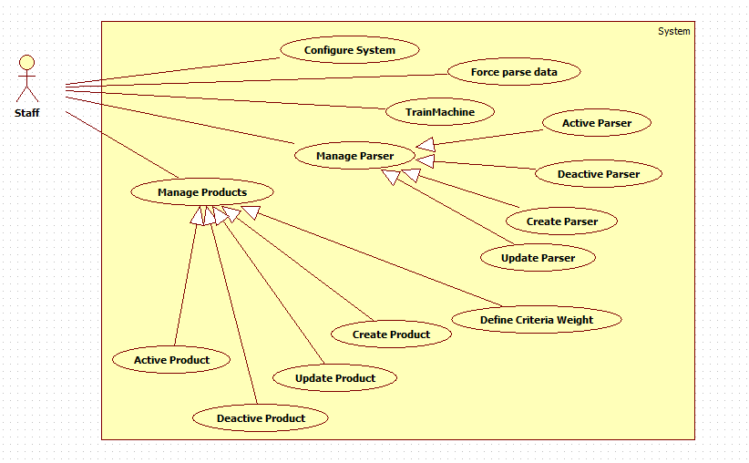

Figure 12: <Staff> Overview Use Case

##### <Staff> Create parser

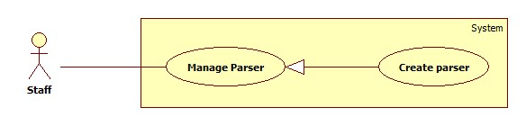

Figure7: <Staff> Create Parser

|  |  |  |  |
| --- | --- | --- | --- |
| **USE CASE – CPS005** | | | |
| **Use Case No.** | CPS005 | **Use Case Version** | 1.0 |
| **Use Case Name** | Create Parser | | |
| **Author** | Pham Hong Sang | | |
| **Date** | 02/06/2014 | **Priority** | High |
| **Actor:**   * Staff.   **Summary:**   * This use case allows staff to create new parser.   **Goal:**   * New parser will be created.   **Triggers:**   * Staffs want to create a new parser to get data from a website. * Staff clicks “Tạo parser” sub menu.   **Preconditions:**   * User has logged in with staff role.   **Post Conditions:**   * **Success**: New parser is added to the system. Show success message. * **Fail:** Show error message.   **Main Success Scenario:**   |  |  |  | | --- | --- | --- | | Step | Actor Action | System Response | | 1 | Staff clicks “Quản lí parser” in menubar. | Show sub menu which includes:   * Tạo parser: submenu. * Danh sách parser: submenu. | | 2 | Staff clicks “Tạo parser” sub menu. | Show “Tạo Parser” page which includes:   * Link cần lấy: text box, min length: 1, max length: 300, required. * Xem: button | | 3 | Staff enters a link and click “Xem” button. | Show “Tạo Parser” page which includes:   * Link cần lấy: display entered value. * Xem: button. * Wizard to create parser. * A frame to show staff’s selected page.   [Alternatvie 1]  [Exception 1] | | 4 | At parse data page, staff input an URL of product into textbox in “Đường dẫn sản phẩm” panel, then click “Xem trước” button. | * Show “Các bước parse dữ liệu” panel includes a wizard to create a parser with 8 steps. * Show “Xem trước” panel include a frame preview the page of the URL which staff inputted. | | 5 | At step 1: “Loại parser” of the wizard, staff select “Dạng lưới” or “Dạng bảng” radio button, then click “Tiếp theo” button. | * Show step 2 of the wizard: “Khung thông tin” includes “Xpath tới khung thông tin” textbox, required. * Show “Xem trước” panel include a frame preview the page of the URL which staff inputted. | | 6 | At step 2: “Khung thông tin”, staff clicks the mouse at the area which includes all of the information of product in “Xem trước” panel, then click “Tiếp theo” button. | * Textbox “Xpath tới khung thông tin” filled with the xpath string, required. * Show step 3 of the wizard: “Tên sản phẩm” includes “Xpath tới tên sản phẩm” textbox. * Show “Xem trước” panel includes a frame preview the page of the URL which staff inputted. * [Exception 2] | | 7 | At step 3: “Tên sản phẩm”, staff clicks the mouse at the area which include product’s name in “Xem trước” panel, then click “Tiếp theo” button. | * Textbox “Xpath tới tên sản phẩm” filled with the xpath string, required. * Show step 4 of the wizard: “CPU” includes “Xpath tới CPU” textbox. * Show “Xem trước” panel includes a frame preview the page of the URL which staff inputted. * [Exception 3] | | 8 | At step 4: “CPU”, staff clicks the mouse at the area which include CPU information in “Xem trước” panel, then click “Tiếp theo” button. | * Textbox “Xpath tới CPU” filled with the xpath string, required. * Show step 5 of the wizard: “RAM” includes “Xpath tới RAM” textbox. * Show “Xem trước” panel includes a frame preview the page of the URL which staff inputted. * [Exception 4] | | 9 | At step 5: “RAM”, staff click the mouse at the area which include RAM information in “Xem trước” panel, then click “Tiếp theo” button. | * Textbox “Xpath tới RAM” filled with the xpath string, required. * Show step 6 of the wizard: “Card màn hình” includes “Xpath tới Card màn hình” textbox. * Show “Xem trước” panel includes a frame preview the page of the URL which staff inputted. * [Exception 5] | | 10 | At step 6:”Card màn hình”, staff click the mouse at the area which include VGA information in “Xem trước” panel, then click “Tiếp theo” button. | * Textbox “Xpath tới card màn hình” filled with the xpath string, required. * Show step 7 of the wizard: “Độ phân giải màn hình” includes “Xpath tới độ phân giải màn hình” textbox. * Show “Xem trước” panel includes a frame preview the page of the URL which staff inputted. * [Exception 6] | | 11 | At step 7: ”Độ phân giải màn hình”, staff click the mouse at the area which include screen resolution information in “Xem trước” panel, then click “Tiếp theo” button. | * Textbox “Xpath tới độ phân giải màn hình” filled with the xpath string, required. * Show step 8 of the wizard: “Giá sản phẩm” includes “Xpath tới giá sản phẩm” textbox. * Show “Xem trước” panel includes a frame preview the page of the URL which staff inputted. * [Exception 7] | | 12 | At step 8:”Giá sản phẩm”, staff click the mouse at the area which include product’s price information in “Xem trước” panel, then click “Tiếp theo” button. [Alternative 2] | * Textbox “Xpath tới giá sản phẩm” filled with the xpath string, required. * Show “Hoàn thành” button. * Show “Xem trước” panel includes a frame preview the page of the URL which staff inputted. | | 13 | Staff click “Hoàn thành” button. | * Send request to the parsed link. * Fetch data from the response based on the inputted XPaths. * Validate data [Exception 8]. * If data is valid, insert to database [Alternative 3]. |   **Alternative Scenario:**   |  |  |  | | --- | --- | --- | | Step | Actor Action | System Response | | 1 | Staff inputted value then did not click on “Tạo” button. | * Do nothing. | | 2 | At step 8: ”Giá sản phẩm”, staff click “Tiếp theo” button. [Alternative 3] | * Show “Hoàn thành” button. * Show “Xem trước” panel includes a frame preview the page of the URL which staff inputted. | | 3 | Staffs follow the wizard to complete the process, then click “Hoàn thành” button. | * If data is valid, insert to database. |   **Exceptions:**   |  |  |  | | --- | --- | --- | | Step | Actor Action | System Response | | 1 | “Link cần lấy” is a blank. | * Show message error:”Vui long nhập thông tin vào ô Link cần lấy”. | | 2 | “Xpath tới khung thông tin” is a blank. | * Show message error:”Vui long nhập thông tin vào ô Xpath tới khung thông tin”. | | 3 | “Xpath tới tên sản phẩm” is a blank. | * Show message error:”Vui long nhập thông tin vào ô Xpath tới tên sản phẩm”. | | 4 | “Xpath tới CPU” is a blank | * Show message error:”Vui long nhập thông tin vào ô Xpath tới CPU”. | | 5 | “Xpath tới RAM” is a blank | * Show message error:”Vui long nhập thông tin vào ô Xpath tới RAM”. | | 6 | “Xpath tới card màn hình” is a blank. | * Show message error:”Vui long nhập thông tin vào ô Xpath tới card màn hình”. | | 7 | “Xpath tới độ phân giải màn hình” is a blank. | * Show message error:”Vui long nhập thông tin vào ô Xpath tới độ phân giải màn hình”. | | 8 | Data is not valid. | * Don’t insert to database. |   **Relationships:** N/A  **Business Rules:**   * The data display structure of that page should be for a specified product. * If the value of RAM, product’s price is negative or not a number, consider invalid.   CPS Success Log File  ======================  -Xpath was created successfully  - Parsing time:[start_time]  - Staff: [username]  ======================  [Parsing link]  - Parsing status:  + Ten san pham: [prodname]  + CPU: [cpu]  + RAM: [ram]  + VGA: [vga]  + Do phan giai: [display]  + Gia san pham: [price]  - Time elapsed: [time_elapsed]  ======================   * Fail log file structure:   CPS Fail Log File  ======================  - Xpath was created successfully but parsing fail  - Parsing time:[start_time]  - Staff: [username]  ======================  [Parsing link]  - Parsing status:  + Ten san pham: [prodname]_[status]  + CPU: [cpu]_[status]  + RAM: [ram]_[status]  + VGA: [vga]_[status]  + Do phan giai: [display]_[status]  + Gia san pham: [price]_[status]  - Time elapsed: [time_elapsed]  ====================== | | | |

Table 5: <Staff> Create Parser

##### <Staff> Update Parser

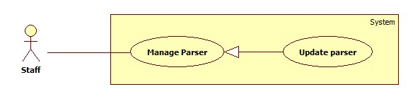

Figure8 : <Staff> Update Parser

|  |  |  |  |
| --- | --- | --- | --- |
| **USE CASE – CPS006** | | | |
| **Use Case No.** | CPS006 | **Use Case Version** | 1.0 |
| **Use Case Name** | Update Parser | | |
| **Author** | Pham Hong Sang | | |
| **Date** | 02/06/2014 | **Priority** | High |
| **Actor:**   * Staff.   **Summary:**   * This use case allows staff to update a parser   **Goal:**   * Selected parser will be updated.   **Triggers:**   * Staff wants to update a parser in the system. * Staff clicks “Chỉnh sửa” link.   **Preconditions:**   * User has logged in with staff role. * There is at least 1 parser which is created before.   **Post Conditions:**   * **Success**: Selected parser will be updated. Show success message. * **Fail:** Show error message.   **Main Success Scenario:**   |  |  |  | | --- | --- | --- | | Step | Actor Action | System Response | | 1 | Staff clicks “Quản lí parser” in menubar. | Show sub menu which includes:   * Tạo parser: submenu. * Danh sách parser: submenu. | | 2 | Staff clicks “Danh sách parser” sub menu. | Show “Danh sách parser” page which includes:   * A table with 4 columns:   + STT  + Link cần lấy  + Trạng thái  + Hành động | | 3 | Staff clicks “Chỉnh sửa” link. | Show “Sửa Parser” page which includes:   * Link cần lấy: display entered value. * Xem: button. * Wizard to create parser. * A frame to show staff’s selected page.   [Exception 1] | | 4 | At parse data page, staff input an URL of product into textbox in “Đường dẫn sản phẩm” panel, then click “Xem trước” button. | * Show “Các bước parse dữ liệu” panel includes a wizard to create a parser with 8 steps. * Show “Xem trước” panel include a frame preview the page of the URL which staff inputted. | | 5 | At step 1: “Loại parser” of the wizard, staff select “Dạng lưới” or “Dạng bảng” radio button, then click “Tiếp theo” button. | * Show step 2 of the wizard: “Khung thông tin” includes “Xpath tới khung thông tin” textbox, required. * Show “Xem trước” panel include a frame preview the page of the URL which staff inputted. | | 6 | At step 2: “Khung thông tin”, staff clicks the mouse at the area which includes all of the information of product in “Xem trước” panel, then click “Tiếp theo” button. | * Textbox “Xpath tới khung thông tin” filled with the xpath string, required. * Show step 3 of the wizard: “Tên sản phẩm” includes “Xpath tới tên sản phẩm” textbox. * Show “Xem trước” panel includes a frame preview the page of the URL which staff inputted. * [Exception 2] | | 7 | At step 3: “Tên sản phẩm”, staff clicks the mouse at the area which include product’s name in “Xem trước” panel, then click “Tiếp theo” button. | * Textbox “Xpath tới tên sản phẩm” filled with the xpath string, required. * Show step 4 of the wizard: “CPU” includes “Xpath tới CPU” textbox. * Show “Xem trước” panel includes a frame preview the page of the URL which staff inputted. * [Exception 3] | | 8 | At step 4: “CPU”, staff clicks the mouse at the area which include CPU information in “Xem trước” panel, then click “Tiếp theo” button. | * Textbox “Xpath tới CPU” filled with the xpath string, required. * Show step 5 of the wizard: “RAM” includes “Xpath tới RAM” textbox. * Show “Xem trước” panel includes a frame preview the page of the URL which staff inputted. * [Exception 4] | | 9 | At step 5: “RAM”, staff click the mouse at the area which include RAM information in “Xem trước” panel, then click “Tiếp theo” button. | * Textbox “Xpath tới RAM” filled with the xpath string, required. * Show step 6 of the wizard: “Card màn hình” includes “Xpath tới Card màn hình” textbox. * Show “Xem trước” panel includes a frame preview the page of the URL which staff inputted. * [Exception 5] | | 10 | At step 6:”Card màn hình”, staff click the mo  use at the area which include VGA information in “Xem trước” panel, then click “Tiếp theo” button. | * Textbox “Xpath tới card màn hình” filled with the xpath string, required. * Show step 7 of the wizard: “Độ phân giải màn hình” includes “Xpath tới độ phân giải màn hình” textbox. * Show “Xem trước” panel includes a frame preview the page of the URL which staff inputted. * [Exception 6] | | 11 | At step 7: ”Độ phân giải màn hình”, staff click the mouse at the area which include screen resolution information in “Xem trước” panel, then click “Tiếp theo” button. | * Textbox “Xpath tới độ phân giải màn hình” filled with the xpath string, required. * Show step 8 of the wizard: “Giá sản phẩm” includes “Xpath tới giá sản phẩm” textbox. * Show “Xem trước” panel includes a frame preview the page of the URL which staff inputted. * [Exception 7] | | 12 | At step 8:”Giá sản phẩm”, staff click the mouse at the area which include product’s price information in “Xem trước” panel, then click “Tiếp theo” button. [Alternative 2] | * Textbox “Xpath tới giá sản phẩm” filled with the xpath string, required. * Show “Hoàn thành” button. * Show “Xem trước” panel includes a frame preview the page of the URL which staff inputted. | | 13 | Staff click “Hoàn thành” button. | * Send request to the parsed link. * Fetch data from the response based on the inputted XPaths. * Validate data [Exception 8]. * If data is valid, insert to database [Alternative 3]. |   **Alternative Scenario:**   |  |  |  | | --- | --- | --- | | Step | Actor Action | System Response | | 1 | Staff inputted value then did not click on “Tạo” button. | * Do nothing. | | 2 | At step 8: ”Giá sản phẩm”, staff click “Tiếp theo” button. [Alternative 3] | * Show “Hoàn thành” button. * Show “Xem trước” panel includes a frame preview the page of the URL which staff inputted. | | 3 | Staffs follow the wizard to complete the process, then click “Hoàn thành” button. | * If data is valid, insert to database. |   **Exceptions:**   |  |  |  | | --- | --- | --- | | Step | Actor Action | System Response | | 1 | “Link cần lấy” is a blank. | * Show message error:”Vui long nhập thông tin vào ô Link cần lấy”. | | 2 | “Xpath tới khung thông tin” is a blank. | * Show message error:”Vui long nhập thông tin vào ô Xpath tới khung thông tin”. | | 3 | “Xpath tới tên sản phẩm” is a blank. | * Show message error:”Vui long nhập thông tin vào ô Xpath tới tên sản phẩm”. | | 4 | “Xpath tới CPU” is a blank | * Show message error:”Vui long nhập thông tin vào ô Xpath tới CPU”. | | 5 | “Xpath tới RAM” is a blank | * Show message error:”Vui long nhập thông tin vào ô Xpath tới RAM”. | | 6 | “Xpath tới card màn hình” is a blank. | * Show message error:”Vui long nhập thông tin vào ô Xpath tới card màn hình”. | | 7 | “Xpath tới độ phân giải màn hình” is a blank. | * Show message error:”Vui long nhập thông tin vào ô Xpath tới độ phân giải màn hình”. | | 8 | Data is not valid. | * Don’t insert to database. |   **Relationships:** N/A  **Business Rules:**   * The data display structure of that page should be for a specified product. * If the value of RAM, product’s price is negative or not a number, consider invalid. * There is at least 1 created parser in database. * Selected parser will be updated new information and insert into database. | | | |

Table 10: <Staff> Update Parser

##### <Staff> Deactivate Parser

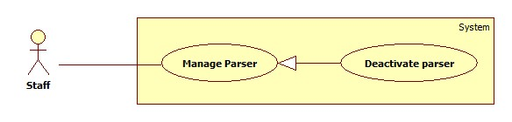

Figure 9: <Staff> Deactivate Parser

|  |  |  |  |
| --- | --- | --- | --- |
| **USE CASE – CPS007** | | | |
| **Use Case No.** | CPS007 | **Use Case Version** | 1.0 |
| **Use Case Name** | Deactivate Parser | | |
| **Author** | Pham Hong Sang | | |
| **Date** | 30/05/2014 | **Priority** | High |
| **Actor:**   * Staff.   **Summary:**   * This use case allows staff to deactivate a parser   **Goal:**   * Selected parser will be deactivated.   **Triggers:**   * Staff wants to deactivate a parser in the system. * Staff clicks “Quản lý parser” menu, clicks “Danh sách parser” then clicks “Hoạt động” button.   **Preconditions:**   * User has logged in with staff role.   **Post Conditions:**   * **Success**: Selected parser is deactivated. Show success message. * **Fail:** Show error message.   **Main Success Scenario:**   |  |  |  | | --- | --- | --- | | Step | Actor Action | System Response | | 1 | Staff clicks “Danh sách parser” sub menu. | Show “Danh sách parser” page which includes:   * A table with 4 columns:   + STT   + Link cần lấy   + Trạng thái   + Hành động | | 2 | Staff clicks “Hoạt động” button.  [Alternative 1]  [Exception 1] | That parser is deactivated. The button text is changed into “Không hoạt động”. Show success message. |   **Alternative Scenario:**   |  |  |  | | --- | --- | --- | | Step | Actor Action | System Response | | 1 | Staff clicks on “Chỉnh sửa”button | * System will redirect to “Chinh sửa” page. |   **Exceptions:**   |  |  |  | | --- | --- | --- | | Step | Actor Action | System Response | | 1 | Error while deactivating parser. | Show error message. |   **Relationships:** N/A  **Business Rules:** Only parsers which have “Hoạt động” status will be deactivated. | | | |

Table 7: <Staff> Deactivate Parser

##### <Staff> Activate Parser

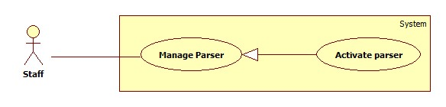

Figure 10: <Staff> Activate Parser

|  |  |  |  |
| --- | --- | --- | --- |
| **USE CASE – CPS008** | | | |
| **Use Case No.** | CPS008 | **Use Case Version** | 1.0 |
| **Use Case Name** | Activate Parser | | |
| **Author** | Pham Hong Sang | | |
| **Date** | 02/06/2014 | **Priority** | High |
| **Actor:**   * Staff.   **Summary:**   * This use case allows staff to activate a parser   **Goal:**   * Selected parser will be activated.   **Triggers:**   * Staff wants to activate a parser in the system. * Staff clicks “Quản lý parser” menu, clicks “Danh sách parser” then clicks “Không hoạt động” button.   **Preconditions:**   * User has logged in with staff role.   **Post Conditions:**   * **Success**: Selected parser is activated. Show success message. * **Fail:** Show error message.   **Main Success Scenario:**   |  |  |  | | --- | --- | --- | | Step | Actor Action | System Response | | 1 | Staff clicks “Danh sách parser” menu. | Show “Danh sách parser” page which includes:   * A table with 4 columns:   + STT   + Link cần lấy   + Trạng thái   + Hành động | | 2 | Staff clicks “Không hoạt động” button.  [Alternative 1]  [Exception 1] | That parser is activated. The button text is changed into “Hoạt động”. Show success message. |   **Alternative Scenario:**   |  |  |  | | --- | --- | --- | | Step | Actor Action | System Response | | 1 | Staff clicks on “Chỉnh sửa”button. | * System will redirect to “Chinh sửa” page. |   **Exceptions:**   |  |  |  | | --- | --- | --- | | Step | Actor Action | System Response | | 1 | Error while activating parser. | Show error message. |   **Relationships:** N/A  **Business Rules:** Only parsers which have “Không hoạt động” status will be activated. | | | |

Table 8: <Staff> Activate Parser

##### <Staff> Configure System

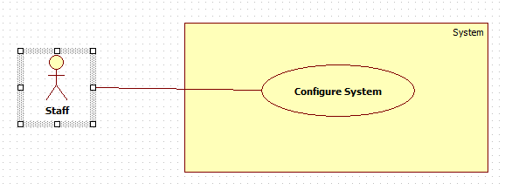

Figure 11: <Staff> Configure System

|  |  |  |  |
| --- | --- | --- | --- |
| **USE CASE – CPS009** | | | |
| **Use Case No.** | CPS009 | **Use Case Version** | 1.0 |
| **Use Case Name** | Configure system | | |
| **Author** | Pham Hong Sang | | |
| **Date** | 02/06/2014 | **Priority** | High |
| **Actor:**   * Staff.   **Summary:**   * This use case allows staff to configure the system.   **Goal:**   * System parameters will be configured by admin.   **Triggers:**   * Staff wants to change system parameter, such as epsilon number,” Số lần được đề cử của mỗi sản phẩm chờ duyệt” or “Số lần được đề cử của một người dùng trên một sản phẩm”. * From the sidebar:   + Choose “Hệ thống” menu.   + Choose “Cấu hình hệ thống” sub-menu.   **Preconditions:**   * User must log in the system with Staff role.   **Post Conditions:**   * **Success:** New parameter will be saved to configuration file. * **Fail:** Nothing is saved to configuration file.   **Main Success Scenario:**   |  |  |  | | --- | --- | --- | | Step | Actor Action | System Response | | 1 | Click at “Cấu hình hệ thống” link in sub-menu. | Show “Cấu hình hệ thống” page which contains:   * Epsilon: textbox, min length: 1, max length: 3, type: integer number, min value: 1, max value: 100, decimal number only, required. * “Số lần đề nghị của một sản phẩm cho 1 người dùng”: textbox, min length: 1, max length: 2, type: integer number, min value: 1, max value: 10, decimal number only, required. * “Số người dùng đề nghị 1 sản phẩm”: textbox, min length: 1, max length: 2, type: integer number, min value: 1, max value: 5, decimal number only, required. * “Thời gian của 1 phiên giao dịch”: drop down box, required, default = “15 minutes”. * Lưu: button. | | 2 | Staff changes system parameters. |  | | 3 | Click on “Lưu” button.  [Exception 1, 2, 3,4,5,6] | * Save data to configuration file. * Show success message. |   **Alternative Scenario:** N/A  **Exceptions:**   |  |  |  | | --- | --- | --- | | No | Actor Action | System Response | | 1 | Epsilon value is out of range. | Show error message: “Epsilon phải lớn hơn 0 và nhỏ hơn hoặc bằng 100!” | | 2 | Epsilon is not a number. | Show error message: “Epsilon phải là số!” | | 3 | “Số lần đề nghị của một sản phẩm cho 1 người dùng” is not a number. | Show error message: “Số lần đề nghị của một sản phẩm cho 1 người dùng.” | | 4 | “Số lần được đề cử của mỗi sản phẩm chờ duyệt” is out of range | Show error message: “Số lần được đề cử của mỗi sản phẩm chờ duyệt phải lớn hơn 1 và bé hơn 10.” | | 5 | “Số người dùng đề nghị 1 sản phẩm” is not a number. | Show error message: “Số người dùng đề nghị 1 sản phẩm phải là số!” | | 6 | “Số người dùng đề nghị 1 sản phẩm” is out of range. | Show error message: “Số người dùng đề nghị 1 sản phẩm phải lớn hơn 1 và bé hơn 10.” |   **Relationships:** N/A  **Business Rules:**   * Epsilon means: total point of the best product in system. * “Số lần đề nghị của một sản phẩm cho 1 người dùng” means: It prevents for 1 user who have try to break out our system by recommending too many time. * “Số người dùng đề nghị 1 sản phẩm” means: It will let us know which product is searched many time by a lot of user. * “Thời gian của 1 phiên giao dịch”: It will help us to scale up or scale down the system when we have a lot of request. | | | |

Table 9: <Staff> Configure System

##### <Staff> Force parse data

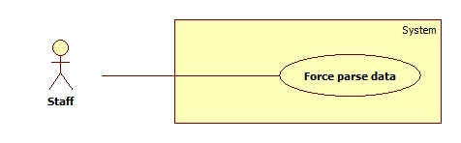

Figure 12: <Staff> Force parses data

|  |  |  |  |
| --- | --- | --- | --- |
| **USE CASE – CPS0010** | | | |
| **Use Case No.** | CPS0010 | **Use Case Version** | 1.0 |
| **Use Case Name** | Force Parse Data | | |
| **Author** | Huynh Thanh Viet | | |
| **Date** | 19/05/2014 | **Priority** | High |
| **Actor:**   * Staff.   **Summary:**   * Staff can force system to parse data at any time.   **Goal:**   * Get data from the url which user suggested.   **Triggers:**   * Staff wants to run the parser at that time. * Staff inputs the url which user suggested to “Đường dẫn sản phẩm” textbox.   **Preconditions:**   * User logged in with “Staff” role.   **Post Conditions:**   * **Success:** New data is inserted to database. Success log file is generated. * **Fail:** Show error message, fail log file is generated.   **Main Success Scenario:**   |  |  |  | | --- | --- | --- | | Step | Actor Action | System Response | | 1 | At parse data page, staff input an url of product into textbox in “Đường dẫn sản phẩm” panel, then click “Xem trước” button. | * Show “Các bước parse dữ liệu” panel includes a wizard to create a parser with 8 steps. * Show “Xem trước” panel include a frame preview the page of the url which staff inputted. | | 2 | At step 1: “Loại parser” of the wizard, staff select “Dạng lưới” or “Dạng bảng” radio button, then click “Tiếp theo” button. | * Show step 2 of the wizard: “Khung thông tin” includes “Xpath tới khung thông tin” textbox. * Show “Xem trước” panel include a frame preview the page of the url which staff inputted. | | 3 | At step 2: “Khung thông tin”, staff click the mouse at the area which include all of the information of product in “Xem trước” panel, then click “Tiếp theo” button. | * Textbox “Xpath tới khung thông tin” filled with the xpath string. * Show step 3 of the wizard: “Tên sản phẩm” includes “Xpath tới tên sản phẩm” textbox. * Show “Xem trước” panel includes a frame preview the page of the url which staff inputted. | | 4 | At step 3: “Tên sản phẩm”, staffs click the mouse at the area which include product’s name in “Xem trước” panel, then click “Tiếp theo” button. | * Textbox “Xpath tới tên sản phẩm” filled with the xpath string. * Show step 4 of the wizard: “CPU” includes “Xpath tới CPU” textbox. * Show “Xem trước” panel includes a frame preview the page of the url which staff inputted. | | 5 | At step 4: “CPU”, staffs click the mouse at the area which include CPU information in “Xem trước” panel, then click “Tiếp theo” button. | * Textbox “Xpath tới CPU” filled with the xpath string. * Show step 5 of the wizard: “RAM” includes “Xpath tới RAM” textbox. * Show “Xem trước” panel includes a frame preview the page of the url which staff inputted. | | 6 | At step 5: “RAM”, staff click the mouse at the area which include RAM information in “Xem trước” panel, then click “Tiếp theo” button. | * Textbox “Xpath tới RAM” filled with the xpath string. * Show step 6 of the wizard: “Card màn hình” includes “Xpath tới Card màn hình” textbox. * Show “Xem trước” panel includes a frame preview the page of the url which staff inputted. | | 7 | At step 6: “Card màn hình”, staffs click the mouse at the area which include VGA information in “Xem trước” panel, then click “Tiếp theo” button. | * Textbox “Xpath tới card màn hình” filled with the xpath string. * Show step 7 of the wizard: “Độ phân giải màn hình” includes “Xpath tới độ phân giải màn hình” textbox. * Show “Xem trước” panel includes a frame preview the page of the url which staff inputted. | | 8 | At step 7: ”Độ phân giải màn hình”, staff click the mouse at the area which include screen resolution information in “Xem trước” panel, then click “Tiếp theo” button. [Alternative 1] | * Textbox “Xpath tới độ phân giải màn hình” filled with the xpath string. * Show step 8 of the wizard: “Giá sản phẩm” includes “Xpath tới giá sản phẩm” textbox. * Show “Xem trước” panel includes a frame preview the page of the url which staff inputted. | | 9 | At step 8: “Giá sản phẩm”, staff click the mouse at the area which include product’s price information in “Xem trước” panel, then click “Tiếp theo” button. [Alternative 2] | * Textbox “Xpath tới giá sản phẩm” filled with the xpath string. * Show “Hoàn thành” button. * Show “Xem trước” panel includes a frame preview the page of the url which staff inputted. | | 10 | Staff click “Hoàn thành” button. | * Send request to the parsed link. * Fetch data from the response based on the inputted XPaths. * Validate data [Exception 1]. * If data is valid, insert to database [Alternative 2]. * Generate success log file. |   **Alternative Scenario:**   |  |  |  | | --- | --- | --- | | Step | Actor Action | System Response | | 1 | At step 7: “Độ phân giải màn hình”, staff click “Tiếp theo” button. [Alternative 1] | * Show step 8 of the wizard: “Giá sản phẩm” includes “Xpath tới giá sản phẩm” textbox. * Show “Xem trước” panel includes a frame preview the page of the url which staff inputted. | | 2 | At step 8: ”Giá sản phẩm”, staff click “Tiếp theo” button. [Alternative 2] | * Show “Hoàn thành” button. * Show “Xem trước” panel includes a frame preview the page of the url which staff inputted. | | 3 | Staffs follow the wizard to complete the process, then click “Hoàn thành” button. | * If data is valid, insert to database [Alternative 3]. * If fetched product is already in the database, update its information. * Generate success log file. |   **Exceptions:**   |  |  |  | | --- | --- | --- | | No | Actor Action | System Response | | 1 | Data is not valid. | * Don’t insert to database. * Generate fail log file. |   **Relationships:** Login  **Business Rules:**   * If the value of RAM, product’s price is negative or not a number, consider invalid. * Success log file structure:   CPS Success Log File  ======================  - Parsing time:[start_time]  - Staff: [staff_username]  ======================  [Parsing link]  - Total items: [total_item]  - Amount of new item: [new_item]  - Amout of update item: [update_item]  - Time elapsed: [time_elapsed]  ======================   * Fail log file structure:   CPS Fail Log File  ======================  - Parsing time:[start_time]  - Staff: [staff_username]  ======================  [Parsing link]  - Total items: [total_item]  - Parsing status:  + Ten san pham: [prodname_status]  + CPU: [cpu_status]  + RAM: [ram_status]  + VGA: [vga_status]  + Do phan giai: [display_status]  + Gia san pham: [price_status]  - Time elapsed: [time_elapsed]  ====================== | | | |

Table 10: <Staff> Force parses data

##### <Staff> Create Product

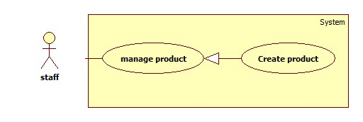

**Figure 13: <Staff> Create Product**

|  |  |  |  |
| --- | --- | --- | --- |
| **USE CASE – CPS0011** | | | |
| **Use Case No.** | CPS0011 | **Use Case Version** | 1.0 |
| **Use Case Name** | Create Product | | |
| **Author** | Ha Chi Danh | | |
| **Date** | 30/05/2014 | **Priority** | Normal |
| **Actor:**   * Staff.   **Summary:**   * This use case allows staff to create product.   **Goal:**   * New product will be added to the database.   **Triggers:**   * Staff wants to create new product. * To input product manually, staff must do the following steps:   + Click “Quản lý sản phẩm” in the menu.   + Click “Tạo sản phẩm” button.   **Preconditions:**   * User must log in the system with staff role.   **Post Conditions:**   * **Success**: New product will be added to the database. * **Fail:** Show error message.   **Main Success Scenario:**   |  |  |  | | --- | --- | --- | | Step | Actor Action | System Response | | 1 | Click “Tạo sản phẩm” button. | Navigate to “Tạo sản phẩm” page which contains:   * Tên sản phẩm: textbox (min length: 5, max length: 50), required. * Tên Hãng: dropdown list. * Chi tiết: rich textbox. * “Thêm sản phẩm” button. * “Thêm hình ảnh” button * “Hủy” button. | | 2 | Enter information into text fields.  Click “Thêm sản phẩm” button to finish. [Alternative 1,2] | System will add product into database.  A new product will be displayed in list product page. Then, redirect to “Quản lý sản phẩm” page. [Exception 1, 2] |   **Alternative Scenario:**   |  |  |  | | --- | --- | --- | | Step | Actor Action | System Response | | 1 | Click on “Hủy” button to finish. | Product is not added. System will return back to “Quản lý sản phẩm” page. | | 2 | Session time out. | Display error message: “Bạn rời máy tính quá lâu, vui lòng đăng nhập lại để tiếp tục”.  Redirect to login page. |   **Exceptions:**   |  |  |  | | --- | --- | --- | | Step | Actor Action | System Response | | 1 | “Tên sản phẩm” is not in range [5, 50]. | Display error message: “Tên sản phẩm phải từ 5 đến 50 ký tự”. | | 2 | “Tên sản phẩm” is a blank. | Display error message: “Vui lòng nhập Tên sản phẩm”. |   **Relationships:** N/A  **Business Rules:**   * Staff clicks on “thêm sản phẩm” button. * System will save new product into database. | | | |

Table 11: <Staff> Create Product

##### <Staff> Update Product

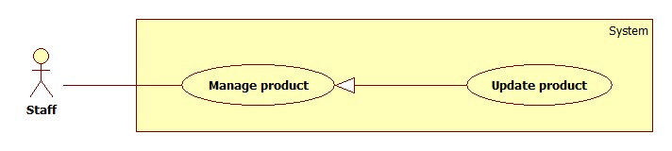

**Figure 14: <Staff> Update Product**

|  |  |  |  |
| --- | --- | --- | --- |
| **USE CASE – CPS0012** | | | |
| **Use Case No.** | CPS0012 | **Use Case Version** |  |
| **Use Case Name** | Update Product | | |
| **Author** | Ha Chi Danh | | |
| **Date** | 30/05/2014 | **Priority** | Normal |
| **Actor:**   * Staff.   **Summary:**   * This use case allows staff to update product information.   **Goal:**   * New information will be updated to selected product.   **Triggers:**   * Staff wants to change product information. * To change product information, staff must do the following steps:   + Choose “Quản lý sản phẩm” in sidebar menu.   + Click at product.   + Change information.   + Click “Cập nhật” button to save new data to database.   **Preconditions:**   * User must log in the system with staff role. * There is at least one product in the database.   **Post Conditions:**   * **Success**: New information will be updated to selected product. * **Fail:** Show error message.   **Main Success Scenario:**   |  |  |  | | --- | --- | --- | | Step | Actor Action | System Response | | 1 | Click “Quản lý sản phẩm” sub-menu. | Navigate to “Quản lý sản phẩm” page which contains:   * A table has 6 columns:   + Số thứ tự.   + Mã Sản phẩm   + Tên sản phẩm.   + Tên Hãng.   + Hình ảnh   + Chi tiết   + Trạng Thái * A drop down list:   + Tìm kiếm bằng tên  + Tìm kiếm bằng hang   * Search: text box. * Tìm kiếm: button | | 2 | Click at any product name. | Navigate to “Thông tin sản phẩm” page which contains:   * Tên sản phẩm: textbox, min length: 5, max length: 50, required. * Tên Hãng: drop down list. * Chi Tiết: rich textbox. * Cập nhật: button. * Hủy: button | | 3 | Click “Cập nhật” button.  [Alternative 1,2] | Save new data to the database. Redirect to “Quản lý sản phẩm” page.[Exception 1, 2] |   **Alternative Scenario:**   |  |  |  | | --- | --- | --- | | Step | Actor Action | System Response | | 1 | Click “Hủy” button. | Redirect to manage product page. | | 2 | Session time out. | Display error message: “Bạn rời máy tính quá lâu, vui lòng đăng nhập lại để tiếp tục”.  Redirect to login page. |   **Exceptions:**   |  |  |  | | --- | --- | --- | | Step | Actor Action | System Response | | 1 | “Tên sản phẩm” is not in range [5, 50]. | Display error message: “Tên sản phẩm phải từ 5 đến 50 ký tự”. | | 2 | “Tên sản phẩm” is a blank. | Display error message: “Vui lòng nhập tên sản phẩm”. |   **Relationships:** N/A.  **Business Rules:**   * Staff clicks “cập nhật” button. * This product will be update information in database. | | | |

Table 12: <Staff> Update Product

##### <Staff> Deactivate Product

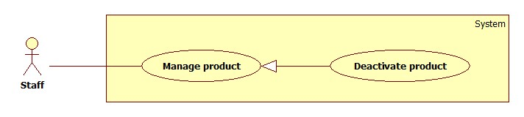

Figure 15: <Staff> Deactivate Product

|  |  |  |  |
| --- | --- | --- | --- |
| **USE CASE – CPS0013** | | | |
| **Use Case No.** | CPS0013 | **Use Case Version** | 2.0 |
| **Use Case Name** | Deactivate Product | | |
| **Author** | Ha Chi Danh | | |
| **Date** | 30/05/2014 | **Priority** | Normal |
| **Actor:**   * Staff.   **Summary:**   * This use case allows staff to deactivate product.   **Goal:**   * Selected product will be deactivated.   **Triggers:**   * Staff wants to deactivate a product in the system. * To deactivate a product, staff must do the following steps:   + Choose “Quản lý sản phẩm” in sidebar menu.   + Click on “Không hoạt động” button.  **Preconditions:**   * User must log in the system with staff role. * There is at least one product activated in database.   **Post Conditions:**   * **Success**: Selected product will be deactivated. * **Fail:** Show error message.   **Main Success Scenario:**   |  |  |  | | --- | --- | --- | | Step | Actor Action | System Response | | 1 | Click “Quản lý sản phẩm” menu. | Navigate to “Quản lý sản phẩm” page which contains:   * A table has 6 columns:   + Số thứ tự.   + Mã Sản phẩm   + Tên sản phẩm.   + Tên Hãng.   + Chi tiết   + Trạng thái * A drop down list:   + Tìm kiếm bằng tên  + Tìm kiếm bằng hang   * Search: textbox * Tìm kiếm: button. | | 2 | Click on “không hoạt động” button. | Deactivate selected product. Show success message.  [Exception 1] |   **Alternative Scenario:**   |  |  |  | | --- | --- | --- | | Step | Actor Action | System Response | | 1 | Session time out | Display error message: “Bạn rời máy tính quá lâu, vui lòng đăng nhập lại để tiếp tục”.  Redirect to login page. |   **Exceptions:**   |  |  |  | | --- | --- | --- | | No | Actor Action | System Response | | 1 | Cannot deactivate product due to database connection problem | Show error message: “Thao tác thất bại. Vui lòng thử lại sau!” |   **Relationships: N/A**  **Business Rules:**   * Staff clicks “Không hoạt động” button. * Button is changed label from “Hoạt động” to ”Không hoạt động” and colour to red. | | | |

Table 13: <Staff> Deactivate Product

##### <Staff> Import file



Figure 16: <Staff> Import file

|  |  |  |  |
| --- | --- | --- | --- |
| **USE CASE – CPS0014** | | | |
| **Use Case No.** | CPS0014 | **Use Case Version** | 1.0 |
| **Use Case Name** | Import file | | |
| **Author** | Tran Tan Len | | |
| **Date** | 1/06/2014 | **Priority** | High |
| **Actor:**   * Staff   **Summary:**   * This use case allows staff upload excel file to server.   **Goal:**   * File will be uploaded to server.   **Triggers:**   * To import a file, staff must do the following steps:   + Click “Nhập từ excel” menu.   + Choose the file, click “Tải lên” button.   **Preconditions:**   * User must log in the system with staff role.   **Post Conditions:**   * **Success**: File will be uploaded to server. * **Fail:** File input is wrong format or file has more than 5 errors. Show error message.   **Main Success Scenario:**   |  |  |  | | --- | --- | --- | | Step | Actor Action | System Response | | 1 | From the staff’s page, staff clicks “Nhập từ Excel” link. | Show “Nhập từ excel” page with 2 buttons:   * “Browse” button. * “Tải lên” button. | | 2 | From “Nhập từ excel” page, staff clicks “Browse” button, then clicks “Mở”. | System will get file path and show excel name on text box. | | 3 | Staff clicks “Tải lên” button. | File is uploaded to server, then redirect back to “Nhập từ excel” page, contains:  * “Danh sách thành phần cấu hình” tab:   * A 5-columns table show detail of product in excel file. Column header includes:   + “STT” label.   + “Tên” label.   + “Trọng số” label.   + “Loại” label.   + “Xóa” button * “Lưu” button. * “Hủy” button.   * “Thành phần cấu hình lỗi” tab.  * “Thành phần cấu hình trùng” tab.  [Exception 1, 2] |   **Alternative Scenario:** N/A  **Exceptions:**   |  |  |  | | --- | --- | --- | | Step | Actor Action | System Response | | 1 | File input is wrong format. | Display error message: “File không đúng định dạng”. | | 2 | File size not range [0- 2] Mb. | Display error message: Kích thước file không được vượt quá 2Mb”. |   **Relationships:** N/A  **Business Rules:**   * Format file is excel (.xlsx/.xls) * Max length of file is 2Mb. * Valid file format : | | | |

Table 14: <Staff> Import File

##### <System> Process data



Figure 17: <System> Process data

|  |  |  |  |
| --- | --- | --- | --- |
| **USE CASE – CPS0015** | | | |
| **Use Case No.** | CPS0015 | **Use Case Version** | 1.0 |
| **Use Case Name** | Process data | | |
| **Author** | Tran Tan Len | | |
| **Date** | 1/06/2014 | **Priority** | High |
| **Actor:**   * System.   **Summary:**   * System can parse data automatically from file and divide data into three lists.   **Goal:**   * Divide data into three lists and show.   **Triggers:**   * System get data from excel file and process.   **Preconditions:**   * Import file is successful.   **Post Conditions:**   * **Success**: Show three list include: * Error product list show on “Danh sách thành phần cấu hình lỗi” tab. * Duplicate product list show on “Danh sách thành phần cấu hình trùng” tab. * Correct product list show on “Danh sách thành phần cấu hình đúng” * **Fail:** File has more than 5 errors. Show error and require staff check file again.   **Main Success Scenario:**   |  |  |  | | --- | --- | --- | | Step | Actor Action | System Response | | 1 | The system checks the newly upload file on server.  The system processes data from file and divide data to three lists. | * System will be showed correct product list on table with 4 columns in “Danh sách thành phần cấu hình đúng” tab:   + “STT”: label.   + “Tên thành phần”: label.   + “Trọng số”: label.   + “Loại”: label.   + “Xóa” button. * System will be showed error product list on table with 4 columns in “Danh sách thành phần cấu hình lỗi” tab:   + “STT” : label   + “Tên thành phần”: textbox (min length: 5 max length: 100, required).   + “Trọng số”: textbox (min length: 1 max length: 100, required).   + “Loại”: textbox (min length: 1 max length: 5, required).   + “Lưu” button. * System will be showed duplicate product lists on tables with 4 columns in “Danh sách thành phần cấu hình trùng” tab: * “Gộp tất cả” button. * “Tách tất cả” button. * “Lưu file” button.   + “Chọn” checkbox.   + “Tên”: textbox (min length: 5 max length: 100, required).   + “Trọng số”: textbox (min length: 1 max length: 100, required).   + “Loại”: textbox (min length: 1 max length: 5, required).   + “Chọn tên chính” radio button.   + “Gộp” button.   + “Tách” button.   [Exception1,2,3,4] |   **Alternative Scenario:** N/A.  **Exceptions:**   |  |  |  | | --- | --- | --- | | Step | Actor Action | System Response | | 1 | “Tên” is not in range [5, 100]. | Display error message: “Tên thành phần phải từ 5 đến 100 ký tự”. | | 2 | “Trọng số” is not in range [1, 300]. | Display error message: “Trọng số phải từ 1 đến 300”. | | 3 | “Loại ”is not in range [1, 5]. | Display error message: “Loại” phải từ 1 đến 5 ký tự”. | | 4 | File has more than 5 errors | Display number of error rows. |   **Relationships:** Login, Import File.  **Business Rules:**   * If system detects more than 5 errors, System will show error. * Else system will show three list include: * System will check and move error products to error products list and show that on “Thành phần cấu hình lỗi” tab. * Error products in excel:   C:\Users\hiepkhach\Desktop\error.png   * System detect by compare product name algorithms and after that move duplicate products to duplicate products list and show that on “Thành phần cấu hình trùng” tab. * Duplicate products in excel:   C:\Users\hiepkhach\Desktop\Duplicate.png   * System will show correct product list on “Thành phần cấu hình đúng” tab. | | | |

Table 15: <System> Process data

##### <Staff> Process error product



Figure 18: <Staff> Process error product

|  |  |  |  |
| --- | --- | --- | --- |
| **USE CASE – CPS0016** | | | |
| **Use Case No.** | CPS0016 | **Use Case Version** | 1.0 |
| **Use Case Name** | Process error product | | |
| **Author** | Tran Tan Len | | |
| **Date** | 1/06/2014 | **Priority** | High |
| **Actor:**   * Staff   **Summary:**   * This use case allows staff to process error products.   **Goal:**   * Get correct product from error products.   **Triggers:**   * Staff wants to fix product information in error product list.   + To process an error product, staff must do the following steps: * Edit product information. * Click “Lưu” button.   **Preconditions:**   * User must log in the system with staff role. * Parse data from excel successful. Error product list is available.   **Post Conditions:**   * **Success**: * Error product will be fixed and transfer to correct product list or duplication product list. * **Fail:** Fixed product still error. Show error message.   **Main Success Scenario:**   |  |  |  | | --- | --- | --- | | Step | Actor Action | System Response | | 1 | Recondition error product list available.  Click “Thành phần cấu hình lỗi” tab. | Interface appears, include table with 4 columns:   * + “STT” : label   + “Tên thành phần”: textbox (min length: 5 max length: 100, required).   + “Trọng số”: textbox (min length: 1 max length: 100, required).   + “Loại”: textbox (min length: 1 max length: 5, required).   + “Lưu” button. | | 2 | Edit product information in row. Then click “Lưu” button | Lưu thì ghi dữ liệu đúng vào list đúng.  Product information will be updated.  System transfer correct product to correct product list.  [Alternative1]  [Alternative2] |   **Alternative Scenario:**  [Alternative1]   |  |  |  | | --- | --- | --- | | Step | Actor Action | System Response | | 1 | Edit product information in row. Then click “Lưu” button | The system will be compared this product name with products in duplicate products list and correct products list. System detects duplicate products. Then move duplicate products to duplicate products list. |   [Alternative2]   |  |  |  | | --- | --- | --- | | Step | Actor Action | System Response | | 1 | Edit product information in row. Then click “Lưu” button | Fixed product still error. Show errors and require staff try again.  [Exception 1, 2, 3] |   **Exceptions:**   |  |  |  | | --- | --- | --- | | Step | Actor Action | System Response | | 1 | “Tên” is not in range [5, 100]. | Display error message: “Tên thành phần phải từ 5 đến 100 ký tự”. | | 2 | “Trọng số” is not in range [5, 100]. | Display error message: “Trọng số phải từ 1 đến 100”. | | 3 | “Loại ”is not in range [1,5]. | Display error message: “Loại” phải từ 1 đến 5 ký tự”. |   **Relationships:** Login, Import File.  **Business Rules:**  **Nếu bị sai thì yêu cầu staff thử lại.**   * System compare products by product name with compare product name algorithms between fixed product and duplicate product list, correct product list. * If systems detect duplicate products, System will move duplicate products to duplicate products list. * Else system will move correct products to list products. | | | |

Table 17: <Staff> Process error product

##### <Staff> Process duplicate product



Figure 19: <Staff> Process duplicate product

|  |  |  |  |
| --- | --- | --- | --- |
| **USE CASE – CPS0017** | | | |
| **Use Case No.** | CPS0017 | **Use Case Version** | 1.0 |
| **Use Case Name** | Process duplicate product | | |
| **Author** | Tran Tan Len | | |
| **Date** | 1/06/2014 | **Priority** | High |
| **Actor:**   * Staff   **Summary:**   * This use case allows staff to process duplicate products.   **Goal:**   * Get correct product from duplicate products.   **Triggers:**   * Staff wants to join or divide products in duplicate products list. * To join products, staff must do the following steps: * Select at least 2 products. * Click “Gộp” button. * To divide products, staff must do the following steps: * Select products by checkbox. * Click “Tách” button.   **Preconditions:**   * User must log in the system with staff role. * Parse data from excel successful. Duplicate product list is available.   **Post Conditions:**   * **Success**:   Duplicate product will be joined or divided and transfer to correct product list.   * **Fail:** Not enough products to join, not yet choose product key name. Show error message.   **Main Success Scenario:**   |  |  |  | | --- | --- | --- | | Step | Actor Action | System Response | | 1 | Recondition duplicate product list available.  Click “Thành phần cấu hình trùng” tab. | Interface appears:   * “Gộp tất cả” button. * “Tách tất cả” button. * “Lưu file” button. * Tables include duplicate product with 5 columns:   + “Chọn” checkbox.   + “Tên”: textbox (min length: 5 max length: 100, required).   + “Trọng số”: textbox (min length: 1 max length: 100, required).   + “Loại”: textbox (min length: 1 max length: 5, required).   + “Chọn tên chính” radio button.   “Gộp” button.  “Tách” button. | | 2 | Select products by checkbox. Then click “Gộp” button.  [Alternative1,2,3,4] | Selected products will be joined. And move to correct products list.  [Exception 4] |   **Alternative Scenario:**   |  |  |  | | --- | --- | --- | | No | Actor Action | System Response | | 1 | Click on “Lưu file” button. | Duplicate products name will be recorded to log file. | | 2 | Click on “Gộp tất cả” button. | All products on each table will be joined. | | 3 | Click on “Tách tất cả” button. | All products on each table will be divided. | | 4 | Select products by checkbox. Then click “Tách” button | Selected products will be divided. And move to correct products list. |   **Exceptions:**   |  |  |  | | --- | --- | --- | | Step | Actor Action | System Response | | 4 | Select at least 2 products | Display error message: “Vui lòng chọn ít nhất 2 sản phẩm”. |   **Relationships:** Login, Import File.  **Business Rules:**   * Products will be joined by product name. * Merge: make two or more names refer to one product. System will be joined products by product name and separated by “;”. Then, system will be move joined products to correct product list. * Split: different names mean different products. System will move both products to correct product list. | | | |

Table 17: <Staff> Process duplicate product

##### <Staff> Save correct product



Figure 20: <Staff>save correct product

|  |  |  |  |
| --- | --- | --- | --- |
| **USE CASE – CPS0018** | | | |
| **Use Case No.** | CPS0018 | **Use Case Version** | 1.0 |
| **Use Case Name** | Save correct products | | |
| **Author** | Tran Tan Len | | |
| **Date** | 1/06/2014 | **Priority** | High |
| **Actor:**   * Staff   **Summary:**   * This use case allows staff adds products to database by import data from excel files.   **Goal:**   * Create many products from imported files.   **Triggers:**   * Staff wants to save correct products by importing excel files. * To save correct products, staff must do the following steps:   + Click “Danh sách thành phần cấu hình đúng” tab.   + Click “Lưu” button.   **Preconditions:**   * User must log in the system with staff role. * Parse data from excel successful. Correct product list is available.   **Post Conditions:**   * **Success**: Products not available in database will be added to the database. Show success message.   Products available in database will be moved to duplicate products list.   * **Fail:** Show error list and require staff try one more time.   **Main Success Scenario:**   |  |  |  | | --- | --- | --- | | Step | Actor Action | System Response | | 1 | Recondition correct product list available.  Click “Danh sách thành phần cấu hình” in menu tab. | File is uploaded to server, then redirect back to “Nhập từ excel” page, contains:   * A 4-columns table show detail of product in excel file. Column header includes:   + STT” label.   + “Tên” label.   + “Trọng số” label.   + “Loại” label.   + “Xóa” button. * “Lưu” button. * “Hủy” button.   [Exception 1, 2, 3] | | 2 | Staff clicks “Xóa” button to delete a product. | The product will be deleted in correct product list. | | 3 | Staff clicks “Lưu” button to save product. [Alternative 1] | Correct product will be inserted into database.  [Alternative2]  [Exception 4] |   **Alternative Scenario:**  [Alternative1]   |  |  |  | | --- | --- | --- | | Step | Actor Action | System Response | | 1 | Click on “Hủy” button to finish. | Refresh current page and clear all. |   [Alternative2]   |  |  |  | | --- | --- | --- | | Step | Actor Action | System Response | | 1 | Staff clicks “Lưu” button to save product. | Compare products in correct products list with database by product name.  Duplicate products will be moved to duplicate products list. |   **Exceptions:**   |  |  |  | | --- | --- | --- | | Step | Actor Action | System Response | | 1 | “Tên” is not in range [5, 100]. | Display error message: “Tên sản phẩm phải từ 5 đến 100 ký tự”. | | 2 | “Trọng số” is not in range [1, 100]. | Display error message: “Trọng số phải từ 1 đến 100”. | | 3 | “Loại ”is not in range [1,5]. | Display error message: “Loại” phải từ 1 đến 5 ký tự”. | | 4 | Fail to insert to database. | Display error message: “Lỗi kết nốt cơ sở dữ liệu vui lòng thử lại”. |   **Relationships:** Login, Import File.  **Business Rules:**   * System will compare correct product list with database by compare string algorithms. * If systems detect duplicate products, System will move duplicate products to duplicate product list. * System will add correct products to database. | | | |

Table 18: <Staff> save correct product

##### <Staff> Write log file



Figure 21: <Staff> Write log file

|  |  |  |  |
| --- | --- | --- | --- |
| **USE CASE – CPS0019** | | | |
| **Use Case No.** | CPS0019 | **Use Case Version** | 1.0 |
| **Use Case Name** | Write log file | | |
| **Author** | Tran Tan Len | | |
| **Date** | 1/06/2014 | **Priority** | High |
| **Actor:**   * Staff   **Summary:**   * This use case allows staff to create log file of duplicate products.   **Goal:**   * Log file will be generated.   **Triggers:**   * Staff wants to create log file of duplicate products. * To create log file, staff must do:   + Click “Lưu file” button.   **Preconditions:**   * User must log in the system with staff role.   **Post Conditions:**   * **Success**: Log file will be generated. Show message. * **Fail:** Show error message and require staff try one more time.   **Main Success Scenario:**   |  |  |  | | --- | --- | --- | | Step | Actor Action | System Response | | 2 | Recondition duplicate product list available.  Click “Sản phẩm trùng” in menu tab. | Redirect to duplicate products list Page, include:  * 3 button :   * + “Gộp tất cả”: button.   + “Tách tất cả”: button.   + “Lưu file”: button   * table duplicate products ,for each row:   * + Checkbox : checkbox   + “STT” label.   + “Tên” label.   + “Trọng số” label.   + “Loại” label.   + “Gộp”: button.   + “Tách”: button. | | 3 | Click “Lưu file” button | Products in duplicate products list will be compared with database.  Duplicate products name will be recorded to log file. |   **Alternative Scenario:** N/A  **Exceptions:** N/A  **Relationships:** Login, Import File.  **Business Rules:**  - System recorded log file and staff will use them for training the system then.  - Name of product will be recorded by each row of each table and seceded by “;”.  + Log file format:    - System insert link and log time into database. | | | |

Table 19: <Staff> Write log file

#### < Member> Overview Use Case

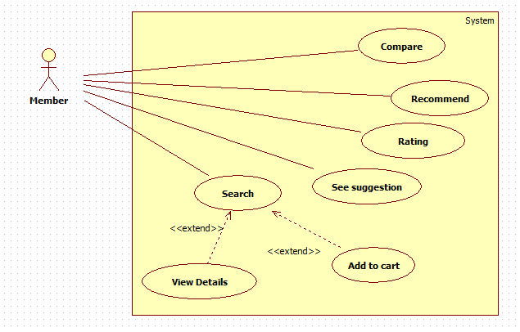

Figure 22: <Member> Overview Use Case

##### <Member> Recommend



Figure 23: <Member> Recommend

|  |  |  |  |
| --- | --- | --- | --- |
| **USE CASE - CPS0020** | | | |
| **Use Case No.** | CPS0020 | **Use Case Version** | 1.0 |
| **Use Case Name** | Recommend | | |
| **Author** | Tran Tan Len | | |
| **Date** | 28/05/2014 | **Priority** | Normal |
| **Actor:**   * Member.   **Summary:**   * This use case allows member to recommend product.   **Goal:**   * New recommendation will be inserted into the database.   **Triggers:**   * Member wants to recommend product for the system. * To recommend, Member must do the following steps:   + From “Không tìm thấy” page:   Member fills data to textboxes in “Nguồn gốc” tab or textboxes in “Cấu hình” tab.  Click “Gửi” button to finish.  **Preconditions:**   * User has logged in system as member role. * Product is not found when member search.   **Post Conditions:**   * **Success**: Recommended product’s detail was sent successfully. Show successful message. * **Fail:** Database connection is not available. Show error message.   **Main Success Scenario:**   |  |  |  | | --- | --- | --- | | Step | Actor Action | System Response | | 1 | Member selected “Nguồn gốc” radio button.  [Alterative1] | Interface appears, include:   * “Email” textbox, min length: 0, max length: 100, regular expression: ^[a-zA-Z0-9.!#$%&'*+/=?^_`{|}~-]+@[a-zA-Z0-9](?:[a-zA-Z0-9-]{0,61}[a-zA-Z0-9])?(?:\.[a-zA-Z0-9](?:[a-zA-Z0-9-]{0,61}[a-zA-Z0-9])?)*$, required. * “Tên laptop” textbox, min length: 6, max length: 30, required. * “Đường dẫn” textbox, min length: 6, max length: 300, regular expression: (http|ftp|https):\/\/[\w\-_]+(\.[\w\-_]+)+([\w\-\.,@?^=%&amp;:/~\+#]*[\w\-\@?^=%&amp;/~\+#])?   , required.   * “Mô tả” textbox, min length: 0, max length: 200. * “Gửi” Button | | 2 | Member fills data to textboxes.  Member clicks “Gửi” Button. | Show success message: “Thao tác thành công!”  Return “Trang chủ” page.  [Exception 1,2,3,5] |   **Alternative Scenario:**  [Alterative1]   |  |  |  | | --- | --- | --- | | Step | Actor Action | System Response | | 1 | Member selected “Cấu hình” radio button. | Interface appears, include:   * “Email” textbox, min length: 0, max length: 100, regular expression: ^[a-zA-Z0-9.!#$%&'*+/=?^_`{|}~-]+@[a-zA-Z0-9](?:[a-zA-Z0-9-]{0,61}[a-zA-Z0-9])?(?:\.[a-zA-Z0-9](?:[a-zA-Z0-9-]{0,61}[a-zA-Z0-9])?)*$, required. * “Tên laptop” textbox, min length: 6, max length: 30, required. * “Hình ảnh” textbox, min length: 6, max length: 300, required. , regular expression: (http|ftp|https):\/\/[\w\-_]+(\.[\w\-_]+)+([\w\-\.,@?^=%&amp;:/~\+#]*[\w\-\@?^=%&amp;/~\+#])? , required. * “Vi xử lý” textbox, min length: 3, max length: 30, required. * “Bộ nhớ” textbox: 3, max length: 30, required. * “Màn hình” textbox, min length: 3, max length: 30, required * “Ổ cứng” textbox, min length: 3, max length: 30, required * “Gửi” Button. | | 2 | Member fills data to text boxes.  Member clicks “Gửi” Button. | Show success message: “Thao tác thành công!”  Return “Trang chủ” page.  [Exception 1,2,3,4,5,6] |   **Exceptions:**   |  |  |  | | --- | --- | --- | | No | Actor Action | System Response | | 1 | Missing information. | Show error message: “Bạn đã điền thiếu thông tin vui lòng nhập đủ thông tin ở ô có dấu * ” | | 2 | Invalid “Email”. | Show error message: “Email không hợp lệ. Vui lòng thử lại!” | | 3 | “Mô Tả” not in range [0, 200]. | Show error message: “Mô Tả không được quá 200 ký tự. Vui lòng thử lại!” | | 4 | TênLaptop/ Cpu/Ram/Display/  HDD is not in range [3, 30]. | Show error message: “Thông tin phải từ 3 tới 30 ký tự. Vui lòng thử lại!” | | 5 | Invalid “Đường dẫn”. | Show error message: “Đường dẫn không hợp lệ. Vui lòng thử lại!” | | 6 | Invalid “Hình ảnh”. | Show error message: “Đường dẫn hình ảnh không hợp lệ. Vui lòng thử lại!” |   **Relationships:** Search.  **Business Rules:**  System will check duplicate between recommended product’s detail in database by “Tên Laptop”  - If system detect duplicated product, system will count times for recommending the product.  + If the time of recommendation is greater than 5, the system will send the request to staff for parsing.  - Else recommendation will be saved recommended product into database | | | |

Table 20: <Member> Recommend

##### <Member> Rating



**Figure 24: <Member> Rating**

|  |  |  |  |
| --- | --- | --- | --- |
| **USE CASE - CPS0021** | | | |
| **Use Case No.** | CPS0021 | **Use Case Version** | 1.0 |
| **Use Case Name** | Rating | | |
| **Author** | Tran Tan Len | | |
| **Date** | 28/05/2014 | **Priority** | Normal |
| **Actor:**   * Member.   **Summary:**   * This use case allows member to rate the product.   **Goal:**   * Rating product.   **Triggers:**   * Member wants to rate the product in system. * For rating product, member must do the following steps:   + View product detail.   + Click rating icon.   **Preconditions:**   * User must log in the system with member role. * View product detail.   **Post Conditions:**   * **Success**: Rating information will be updated in database. * **Fail:** Database connection is not available. Show error message.   **Main Success Scenario:**   |  |  |  | | --- | --- | --- | | Step | Actor Action | System Response | | 1 | From the “Trang chủ”page.  Member clicks “Tên” product or “Hình ảnh” product in list product to view product detail. | Navigate to “Chi Tiết” page which contains:   * Product detail, product weight. * Rating icon. | | 2 | Click “Rating” icon. | Show popup message: “Bạn có chắc chắn với kết quả đánh giá của mình?”   * “Xác Nhận” button. * “Hủy Bỏ” button.   [Exceptions1,2] | | 1 | Click “Xác Nhận” button.  [Alternative1] | New rating will be updated to the database. |   **Alternative Scenario:**   |  |  |  | | --- | --- | --- | | Step | Actor Action | System Response | | 1 | Click “Hủy Bỏ” button | Return to “Chi Tiết” page. |   **Exceptions:**   |  |  |  | | --- | --- | --- | | Step | Actor Action | System Response | | 1 | Database connection is not available. | Show error message: “Không thể đánh giá sản phẩm! Vui lòng thử lại sau.” |   **Relationships:** N/A  **Business Rules:**  Member can rate only 1 time for a product. The Rating help system load bester rating product on home page. | | | |

Table 21: <Member> Rating

##### <Member> Add to Cart

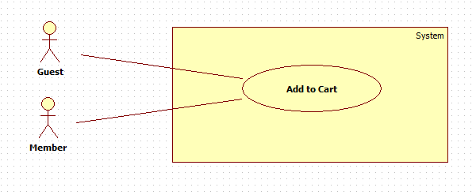

**Figure 25: <Member> Add to cart**

|  |  |  |  |
| --- | --- | --- | --- |
| **USE CASE – CPS0022** | | | |
| **Use Case No.** | CPS0022 | **Use Case Version** | 1.0 |
| **Use Case Name** | Add to Cart | | |
| **Author** | Pham Hong Sang | | |
| **Date** | 28/05/2014 | **Priority** | High |
| **Actor:**   * Guest/Member.   **Summary:**   * This use case allows guest/member to add product to cart.   **Goal:**   * A product will be added to guest/member’s cart.   **Triggers:**   * Guest/Member can add product to cart after search product or add to cart from homepage. * Guest/Member clicks on cart icon button on each result row.   **Preconditions:**   * N/A   **Post Conditions:**   * **Success**: The product will be added to cart. * **Fail:**   + Session is time out.  + System will show message “Your session has expired. Please try again”. Redirect to homepage.  **Main Success Scenario:**   |  |  |  | | --- | --- | --- | | Step | Actor Action | System Response | | 1 | Click cart icon button on result row. | * Check for the existence of the cart object in session [Exception 1]. * Add clicked product to cart [Alternative 1]. * Change the number of product in cart and display it for user. [Exception 2]. |   **Alternative Scenario:**   |  |  |  | | --- | --- | --- | | Step | Actor Action | System Response | | 1 | The product has existed in cart. | * Button “add to cart” will be hidden for preventing to add to cart again. |   **Exceptions:**   |  |  |  | | --- | --- | --- | | Step | Actor Action | System Response | | 1 | Session time out. | * Show pop-up which is included:   + Label:”Giỏ hàng của bạn đã hết phiên giao dịch.Mời bạn thử lại.”  + OK:button.[Exception 3]  + Cancel:button. [Exception 4] | | 2 | Cart is full of products | * Show error message:”Giỏ hàng của bạn chỉ chứa tối đa được 3 sản phẩm.” | | 3 | User clicks ”OK” button | * Create new cart object in session. * Add clicked product to cart. * Change the number of product in cart and display it for user. | | 4 | User clicks “Cancel” button. | * Do nothing. |   **Relationships:** N/A  **Business Rules:**   * Maximum size of cart is 3. * If session is out of time, it will show message for user. System will create a new session automatically when user clicks on “OK” button. * If cart only have 1 product, system will do nothing. System will progress if the size of cart is 2 or above. | | | |

Table 20: <Member> Add to Cart

##### <Member> See suggestion

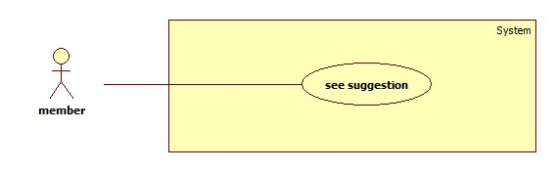

Figure 26: <Member> See suggestion

|  |  |  |  |
| --- | --- | --- | --- |
| **USE CASE – CPS0023** | | | |
| **Use Case No.** | CPS0023 | **Use Case Version** | 1.0 |
| **Use Case Name** | See suggestion | | |
| **Author** | Ha Chi Danh | | |
| **Date** | 30/05/2014 | **Priority** | Normal |
| **Actor:**   * Member.   **Summary:**   * This use case allows member to see suggestion when comparing products on website.   **Goal:**   * Member sees suggestion when comparing products in cart successfully.   **Triggers:**   * When cart has at least 2 products, member clicks “so sánh” button.   **Preconditions:**   * User must login with member role.   **Post Conditions:**   * **Success**:   **+** Show comparison table products.  **+** Show points of product.  **+** Show recommend as list of products.   * **Fail:** Show error message.   **Main Success Scenario:**   |  |  |  | | --- | --- | --- | | Step | Actor Action | System Response | | 1 | * Member adds 2 or 3 products to cart * Member clicks “So sánh” button.   [Alternative 1,2,3] | Navigate to “So sánh” page with contains:   * Comparison table with information:   + Product which is winner and which is (are) runner-up in cart.  + Show Point of products.  + Show recommend as list of products.  [Exception 1] |   **Alternative Scenario:**   |  |  |  | | --- | --- | --- | | No | Actor Action | System Response | | 1 | * Cart has no product. * Member clicks “So sánh” button. | Show error message:” Phải có ít nhất 2 sản phẩm trong giỏ”. | | 2 | * Member adds 1 product to cart. * Member clicks “So sánh” button. | Show error message:” Phải có ít nhất 2 sản phẩm trong giỏ”. | | 3 | Session time out. | Show error message:”Vui lòng đăng nhập lại để được hỗ trợ nhiều hơn”.  Redirect to login page |     **Exceptions:**   |  |  |  | | --- | --- | --- | | No | Actor Action | System Response | | 1 | Cannot compare product due to database connection. | Show error message:”Thao tác thất bại, xin hãy thử lại”. |   **Relationships:** Add to cart  **Business Rules:**  Member adds 2 or 3 products to cart.  Member clicks “So sánh” button, “So sánh” page will show in 2 situations:   * Situation 1: Error message ”Phải có ít nhất 2 sản phẩm trong giỏ” * Situation 2:   + Show comparison table.  + Points of products.  + Show recommend as list of products that similar with products in member’s cart. | | | |

Table 21: <Member> See suggestion

##### <Authorized user> Log out

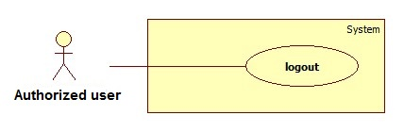

Figure 27: < Authorized user > Logout

|  |  |  |  |
| --- | --- | --- | --- |
| **USE CASE – CPS0024** | | | |
| **Use Case No.** | CPS0024 | **Use Case Version** | 1.0 |
| **Use Case Name** | Logout | | |
| **Author** | Ha Chi Danh | | |
| **Date** | 30/05/2014 | **Priority** | Normal |
| **Actor:**   * Authorized user.   **Summary:**   * This use case allows Authorized user to log out of the system.   **Goal:**   * Authorized user logs out of the system. Authorized user’s current session is destroyed.   **Triggers:**   * Authorized user wants to log out. * Authorized user clicks “Đăng xuất” link.   **Preconditions:**   * Authorized user has logged in to the system.   **Post Conditions:**   * **Success**: Authorized user’s current session is destroyed. Redirect to homepage. * **Fail:** Show error message.   **Main Success Scenario:**   |  |  |  | | --- | --- | --- | | Step | Actor Action | System Response | | 1 | Authorized user clicks “Thoát” link. | Show message “Bạn thực sự muốn thoát”   * Xác nhận: button * Hủy: button | | 2 | Authorized user clicks “Xác nhận” button. [Alternative 1] | Destroy Authorized user’s session. Redirect to homepage. [Exception 1] |   **Alternative Scenario:**   |  |  |  | | --- | --- | --- | | No | Actor Action | System Response | | 1 | Authorized user clicks “Hủy” button. | Do nothing. |   **Exceptions:**   |  |  |  | | --- | --- | --- | | No | Actor Action | System Response | | 1 | Fail to destroy Authorized user’s session | Redirect to error page. |   **Relationships:** N/a  **Business Rules:**   * Authorized user clicks “thoát” link, * Authorized user’s role will be changed to guest. | | | |

Table 24: <Authorized user> Logout

##### <Authorized user> Change Password

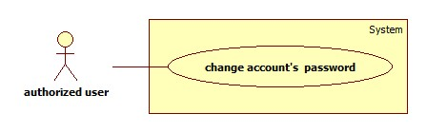

**Figure 28: < Authorized user > Change Password**

|  |  |  |  |
| --- | --- | --- | --- |
| **USE CASE – CPS0025** | | | |
| **Use Case No.** | CPS0025 | **Use Case Version** | 1.0 |
| **Use Case Name** | Change password | | |
| **Author** | Ha Chi Danh | | |
| **Date** | 30/05/2014 | **Priority** | Normal |
| **Actor:**   * Authorized user.   **Summary:**   * This use case allows Authorized user to change password.   **Goal:**   * Authorized user changes password successfully.   **Triggers:**   * Authorized user logins to website. * Authorized user clicks “Thay đổi mật khẩu” link.   **Preconditions:** Authorized user has register into the system.  **Post Conditions:**   * **Success:** New password has been updated into database. * **Fail:** Show error message.   **Main Success Scenario:**   |  |  |  | | --- | --- | --- | | Step | Actor Action | System Response | | 1 | Authorized user clicks “Thay đổi mật khẩu” link. | Show “Thay đổi mật khẩu ” page with includes:   * Mật khẩu cũ: textbox, password box, min length: 6, max length: 20, required. * Mật khẩu mới: textbox, password box, min length: 6, max length: 20, required. * Xác nhận mật khẩu mới: textbox, password box, min length: 6, max length: 20, required. * Thay đổi: button. * Xóa trắng: button. | |  | Authorized user clicks “Thay đổi” button [Alternative 1] | Show successful message and return to home page. [Exception 1,2, 3,4,5,6] |   **Alternative Scenario:**   |  |  |  | | --- | --- | --- | | No | Actor Action | System Response | | 1 | Authorized user clicks “Xóa trắng” button. | Clear all input fields. |   **Exceptions:**   |  |  |  | | --- | --- | --- | | No | Actor Action | System Response | | 1 | Length of password is not in range. | Show error message: “Độ dài mật khẩu phải từ 6-20 ký tự!” | | 2 | “Mật khẩu cũ” is wrong. | Show error message:”Sai mật khẩu.” | | 3 | “Mật khẩu cũ” is a blank. | Show error message:”Vui lòng nhập mật khẩu” | | 4 | “Mật khẩu mới” is a blank. | Show error message:”Vui lòng nhập mật khẩu mới” | | 5 | “Xác nhận mật khẩu mới” is a blank. | Show error message:”Vui lòng nhập xác nhận mật khẩu mới” | | 6 | “Mật khẩu mới” and “Xác nhận mật khẩu mới” is not similar. | Show error message: “Mật khẩu mới và Xác nhận mật khẩu mới không trùng khớp”. |   **Relationships:** N/A  **Business Rules:**   * Authorized user click “Thay đổi” button * New password has been updated into database. | | | |

Table 25: <Authorized user> Change Password

#### <Guest> Overview Use Case

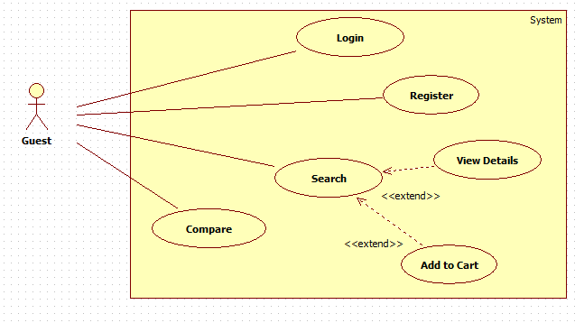

Figure 29: <Guest> Overview Use Case

##### <Guest> Register

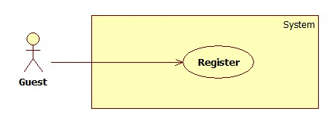

Figure 30: <Guest> Register

|  |  |  |  |
| --- | --- | --- | --- |
| **USE CASE – CPS0026** | | | |
| **Use Case No.** | CPS0026 | **Use Case Version** | 1.0 |
| **Use Case Name** | Register | | |
| **Author** | Ha Chi Danh | | |
| **Date** | 30/05/2014 | **Priority** | Normal |
| **Actor:**   * Guest.   **Summary:**   * This use case allows guest to register.   **Goal:**   * User can register new account to become a member of the system.   **Triggers:**   * Guest wants to be a member of the system. * To register, click “Đăng ký” link in menu bar.   **Preconditions:** N/A.  **Post Conditions:**   * **Success:** New member account is created. * **Fail:** Show error message.   **Main Success Scenario:**   |  |  |  | | --- | --- | --- | | Step | Actor Action | System Response | | 1 | Guest clicks “Đăng ký” link. | System show a register form which includes:   * Username: textbox, min length: 6, max length: 30, required. * Password: textbox, password box, min length: 6, max length: 20, required. * Đăng ký: button. * Xóa trắng: button. | | 2 | Guess enters required information, then clicks “Đăng ký” button. [Alternative 1] | Create new member account. Show success message.  [Exception 1,2, 3] |   **Alternative Scenario:**   |  |  |  | | --- | --- | --- | | No | Actor Action | System Response | | 1 | Guest clicks “Xóa trắng” button. | Clear all input fields. |   **Exceptions:**   |  |  |  | | --- | --- | --- | | No | Actor Action | System Response | | 1 | Length of username is not in range. | Show error message: “Độ dài username phải từ 6-30 ký tự!” | | 2 | Length of password is not in range. | Show error message: “Độ dài password phải từ 6-20 ký tự!” | | 3 | Username’s existed already. | Show error message: “Trùng tên đăng nhập! Vui lòng chọn tên khác!” |   **Relationships:** N/A  **Business Rules:**   * The role of new created account is “member”. | | | |

Table 26: <Guest> Register

##### <Guest> Login

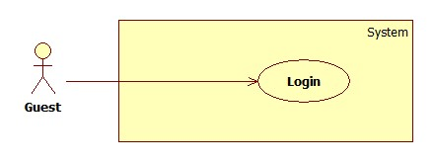

Figure 31: <Guest> Login

|  |  |  |  |
| --- | --- | --- | --- |
| **USE CASE – CPS0027** | | | |
| **Use Case No.** | CPS0027 | **Use Case Version** | 1.0 |
| **Use Case Name** | Login | | |
| **Author** | Ha Chi Danh | | |
| **Date** | 30/05/2014 | **Priority** | Normal |
| **Actor:**   * Guest.   **Summary:**   * This use case allows guest to login to the system.   **Goal:**   * Allow authentication and authorization of the system.   **Triggers:**   * Guest want to login into system. * To login: Guests go to the login link, enter username and password, and click “Đăng nhập” button to login.   **Preconditions:**   * Database has a registered account.   **Post Conditions:**   * **Success:** Guest is authorized, redirect to corresponding page. * **Fail:** System will show error on current page.   **Main Success Scenario:**   |  |  |  | | --- | --- | --- | | Step | Actor Action | System Response | | 1 | Guest goes to login page. | System show a login form, includes:   * Username: textbox, min length: 6, max length: 30, required. * Password: textbox, password box, min length: 6, max length: 20, required. * Đăng nhập: button. * Hủy: button * Create new account. | | 2 | Guess enter username and password into textboxes.  Press “Đăng nhập” button.[Alternative 1] | * Show message successful * “Ghi nhớ tài khoản”: check box   [Exception 1,2,3,4] |   **Alternative Scenario:**   |  |  |  | | --- | --- | --- | | No | Actor Action | System Response | | 1 | Press “Cancel” button. | Navigate to home page. |   **Exceptions:**   |  |  |  | | --- | --- | --- | | No | Actor Action | System Response | | 1 | “Tên tài khoản” is a blank | Show error message: “Vui lòng điền đủ username và password!” | | 2 | “Mật khẩu” is a blank | Show error message: “Vui lòng điền đủ username và password!” | | 3 | Username/Password not in range [5,30] | Show error message: “Thông tin không hợp lệ. Vui lòng thử lại!” | | 4 | Invalid “Username” and “Password” | Show error message: “Thông tin không hợp lệ. Vui lòng thử lại!” |   **Relationships:** N/A.  **Business Rules:**   * Each member, staff, admin has an account. * Only active account can log in. | | | |

Table 25: <Guest> Login

##### <Guest> View Detail

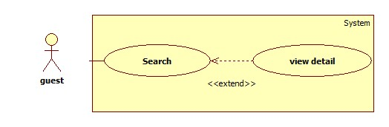

**Figure 32: <Guest> View Detail**

|  |  |  |  |
| --- | --- | --- | --- |
| **USE CASE – CPS0028** | | | |
| **Use Case No.** | CPS0028 | **Use Case Version** | 1.0 |
| **Use Case Name** | View detail | | |
| **Author** | Ha Chi Danh | | |
| **Date** | 30/05/2014 | **Priority** | Normal |
| **Actor:**   * Guest.   **Summary:**   * This use case allows guest to search and view product information.   **Goal:**   * A page detail of products will be shown to guest.   **Triggers:**   * Guest inputs to a blank textbox then clicks “Tìm kiếm” button. * Guest inputs URL of product or serial number then they search all products with relative URL or serial number which they inputted. The searching results will show product detail.   **Preconditions:** N/A  **Post Conditions:**   * **Success**: Show search results as a page of product with URL or serial number that guest inputted * **Fail:** Show an error message.   **Main Success Scenario:**   |  |  |  | | --- | --- | --- | | Step | Actor Action | System Response | | 1 | Guest inputs the product’s URL or serial number into textbox. | Show “Search” page with includes:   * Tìm bằng đường dẫn/ tìm bằng số seri: drop down list. * Search: textbox * Tìm kiếm: button | | 2 | Guest clicks “Tìm kiếm” button. | * System will show page detail product by product URL or serial number.[Exception1] |   **Alternative Scenario:** N/A  **Exceptions:**   |  |  |  | | --- | --- | --- | | Step | Actor Action | System Response | | 1 | Search not found | Redirect to Not found page.  Show message:”Vui lòng đăng nhập để được hỗ trợ nhiều hơn”. |   **Relationships:** Search  **Business Rules:**   * User search by URL or serial number of product * System will search all products in database. * If that product is existed, system will show detail page of that product. | | | |

Table 28: <Guest> View Detail

## Software System Attribute

### Usability

#### Graphic User Interface

* All the texts, labels and should be written in Vietnamese.

#### Usability

* Admin, staff should need less than one week of training to be productive with the system.
* Guest and member can use the system easily without training.

#### Installation

* The system must be easy to deploy. Customer can deploy successfully and learn to configure, maintain the system within one day of training.
* The mobile app must be easy to install. Compatible with almost Android Phone.
* The attached manual guide must be clear. User can read and do themselves without developer’s help.

### Reliability

* N/A

### Availability

* N/A

### Security

* Privacy: Each role of user has a specific permission to interact with system.
* System always checks authorization and authenticated before doing anything.
* Only admin can grant permission to staff.

### Maintainability

* N/A

### Portability

* N/A

### Performance

* N/A

## ERD

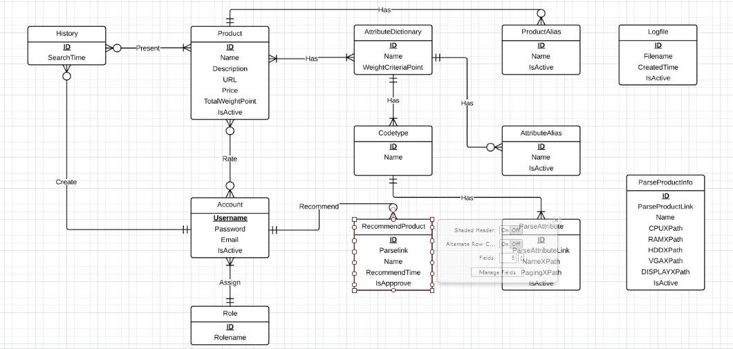

Figure 35: ERD - Conceptual Diagram